Ideation Phase
Define the Problem Statements

Date | 27 June 2026
Team ID
Project Name | Strategic Product Placement Analysis
Maximum Marks | 2 Marks

Customer Problem Statement Template:
Create a problem statement to understand your customer's point of view. The Customer Problem Statement template helps you focus on what matters to create experiences people will love.
A well-articulated customer problem statement allows you and your team to find the ideal solution for the challenges your customers face. Throughout the process, you’ll also be able to empathize with your customers, which helps you better understand how they perceive your product or service.

Reference: https://miro.com/templates/customer-problem-statement/
Example:
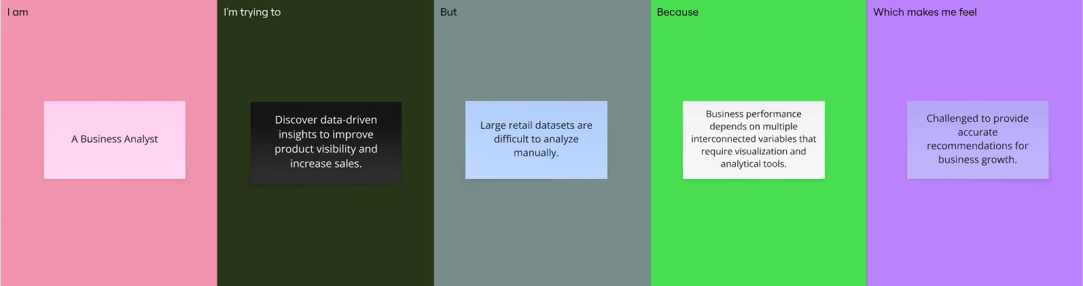
Problem Statement (PS) | I am (Customer) | I’m trying to | But | Because | Which makes me feel
PS-1 | A Retail Store Manager responsible for product placement and merchandising strategies. | Identify the most effective product placement strategy that maximizes sales and improves customer shopping experience. | I struggle to determine which shelf positions and product categories generate the highest sales and revenue. | Sales performance is influenced by product position, pricing, promotions, foot traffic, competitor pricing, and customer demographics, making manual analysis difficult. | Uncertain about merchandising decisions and worried about losing potential sales and revenue opportunities.
PS-2 | A Retail Business Analyst responsible for analyzing store performance and supporting business decisions. | Analyze retail data to identify actionable insights that optimize product placement and increase overall sales. | It is difficult to identify meaningful patterns from large retail datasets using traditional analysis methods. | Multiple interconnected business factors influence sales, requiring visualization and data analytics to support better decision-making. | Challenged to provide accurate recommendations that improve profitability and customer satisfaction.

